Wallace Visual Editor

How many hours have each of us spent creating a user interface for an application that we have made? Including making drawing routines, a state machine, and a set of listeners I’ll bet that about half of the time making a good application is spent making all of this junk (in my experience even more, about three quarters.) For a large project that could amount to maybe five or even ten hours of coding, testing, and debugging. Now if there was a way to compress that down to about ten minutes imaging what we could accomplish.
That is why I wrote Wallace Visual Editor. It is a drag and drop tool that allows you to make a beautiful user interface in minutes. It will do everything for you, give you drawing routines, will write a state machine, make a listener for every object, and even comment the code for you.

A Visual Editor is a tool that most programmers have used at one point or another. Visual Studios is a popular one as well as Eclipse VE. They allow you to quickly select a portion of the screen with the mouse and turn that selected area into a Windows object as well as set flags and other aspects of the object. It is called a visual editor because you can see what your application is going to look like long before you even think about code. Most Visual Editors are for object oriented languages so it is easy to use the window once you created it. As far as I know there is one visual editor available for FreeBasic that allows you to use real Windows objects. I found this frustrating though, because who needs an application with nothing but buttons and checkboxes? Not me, I have to be able to display something.
The Windows objects act just like they are: objects. FreeBasic is a module based language. This gives us extreme difficulties when we try to display something on the windows created by visual edits such as EzeeGUI. Windows don’t use buffers; they use objects called “frames”. LINE and PSET don’t work on these frames. In order to display something on the window you would have to first put in on a buffer, then use a library from an OOP language to put it through a “wrapper” to convert it into a graphic configuration or graphics view which can then be put on the screen. Wallace Visual Editor ignores the frame and uses a normal Screenres command to make the window. All of your graphics commands will work.

Getting Started

If you downloaded Wallace VE when it first came out the first thing that you will want to do is to go to my website www.freewebs.com/wallacesoftware and grab a copy of Wallace VE 1.1. Don’t worry; if you have a project saved it will still work in WVE 1.1. Now run it and type in the size of the window that you want, if you bypass this step by pressing enter twice you will get a window of size 800x600.
Now let’s first make a File menu. Click on the Menu Button and you will see a prompt near where the menu will be asking you to give the menu a name. I type in “File” and press enter. You have to know ahead of time how many options there are going to be, I typed in 5 at the number command. Then I went through the prompts putting in 5 commands one at a time. I chose New, Open, Save, Save As, and Quit. It seemed like a pretty standard File menu. Here already WVE has done something cool for you. It has automatically coded the commands Open, Save As, and Quit. They will all do the appropriate action.

Now to make an object you need to select an area of the screen by clicking and dragging. A blue outline will show up so that you can see how big it is. Now all of the buttons light up.

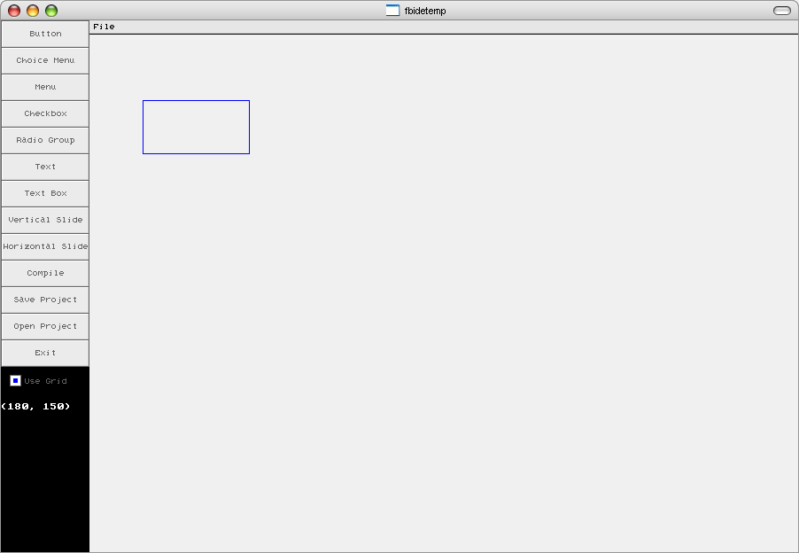

I think I’ll make this object a button. I select the Button button and give it the caption “Button #1.” Right away the button is shown on the screen. But I don’t like its position. So I click on the button and drag it to the top left corner underneath the File menu. I also decide to give it a companion; I made another button directly underneath it.

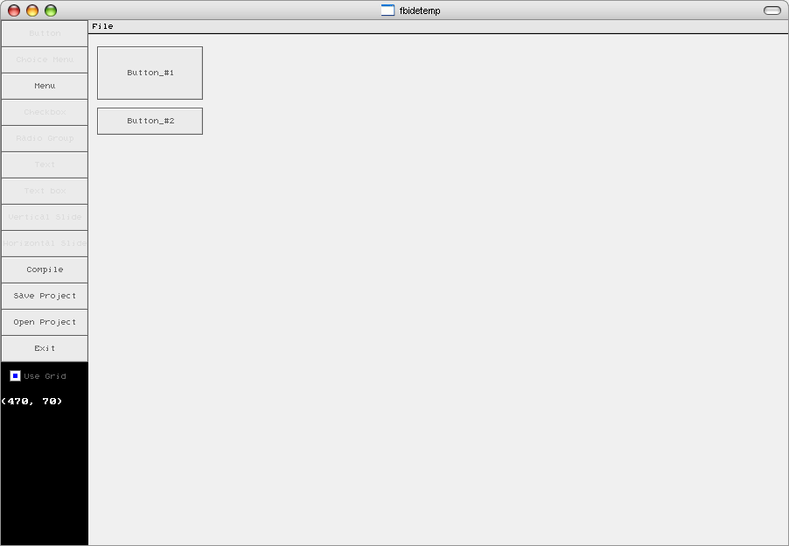

Notice that I decided to leave the Use Grid checkbox selected, this forces the object o snap to the neared 10 pixels, this makes it easier to make a nice neat workspace. Next to these buttons I make a textbox and another button labeled “Browse.” This does something else cool. The Browse button will automatically open an Open window and place the name of the selected file in the textbox next to it. I now decide that I don’t want the use to be able to press the big button at the moment, so I right click on it and a menu pops up and I select toggle active state.

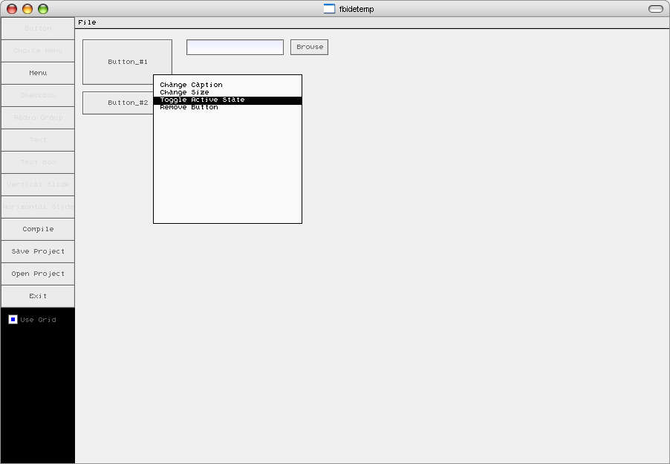

So now I add a vertical slider bar with an upper bound of 100 and place text on top of it labeling it “WVE’s coolness, but there is a problem. Well two problems. For one the coolness slider is at zero and that can’t be right, but also you can’t see all of the text, I selected too small of an area for it.

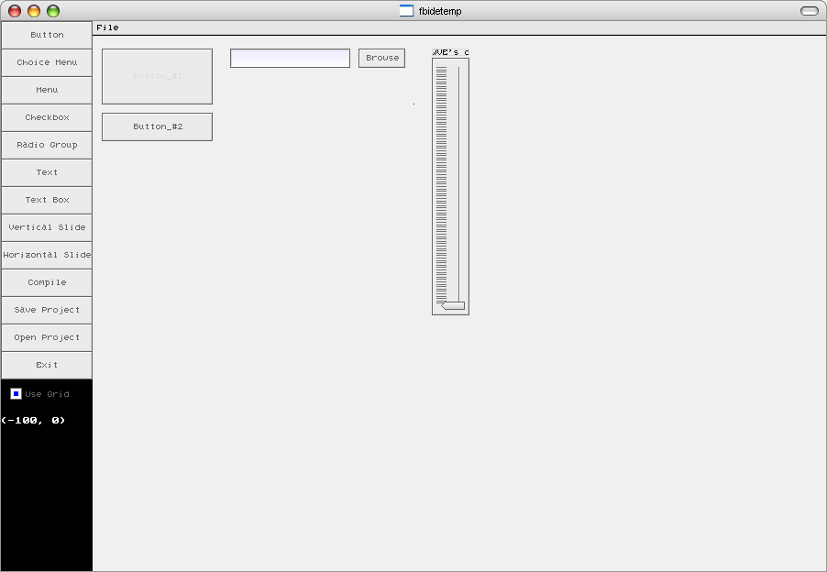

Not to worry, I right click on the slider bar and select the menu option “Change Position.” I type in the new position at 99. For the text I select “Move Cutoff Point” and use the arrow keys to change the place where the text gets cut off. I also centre the text and change its colour to a nice blue. Now I make some more miscellaneous objects and an Edit menu the same way that I make everything else.

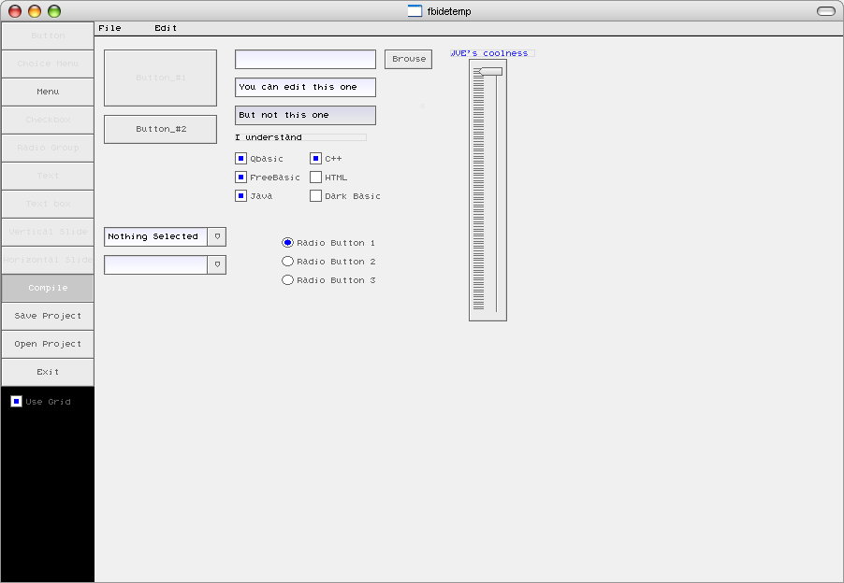

Now I hit the Compile button and open the file called WallaceVEcode.bas. If you don’t see that file then that means that you saved the project into a different folder and the code is located there as well. And Voila! Almost 1000 lines of code that I didn’t have to write. The whole thing took about 3 minutes to put together in Wallace VE.

Now you can run it, if you don’t see any text then you have to copy roman.fnt into the same folder as the source code. Here is the program running and I have selected File>Open and the open window has shown up as expected. Everything works, you can type text into the text boxes except for the inactive one, check and uncheck the checkboxes, move the slider, etc without me having to do any coding at all.

